GIT and GITHUB-02
- Install git.
- Download Git git-scm.com/downloads/win
- Check installation git --version
- Set username git config --global user.name "Your Name"
- Set email git config --global user.email "your-email@example.com"
- View configuration git config --global --list
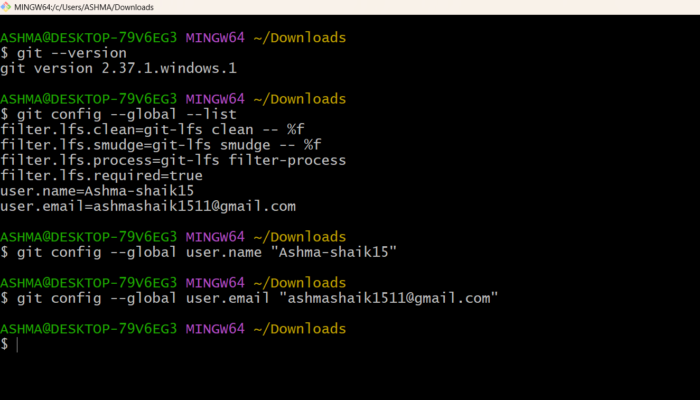
2.Create a repo in github with README.md and .ignore file.
- Created new repository Devops-practice
- Add description my git Devops-practice project
- Enabled README.md
- Enabled .gitignore select python
- Click creat repository
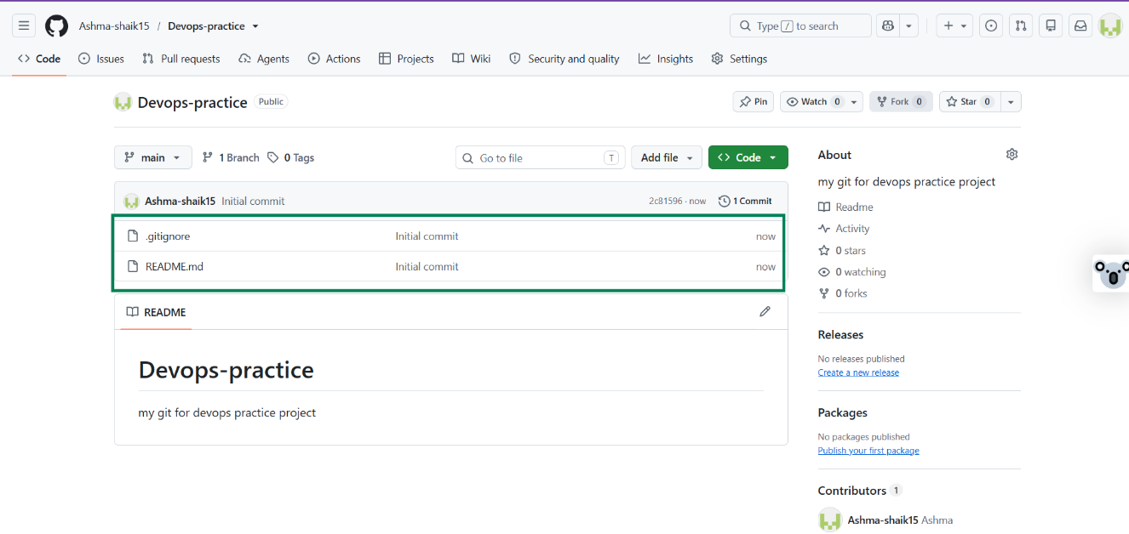

- Clone the created repo to local.
- Create repository “Devops-practice”
- To download the source code from the repository to the local machine
- Git clone “paste ssh url”
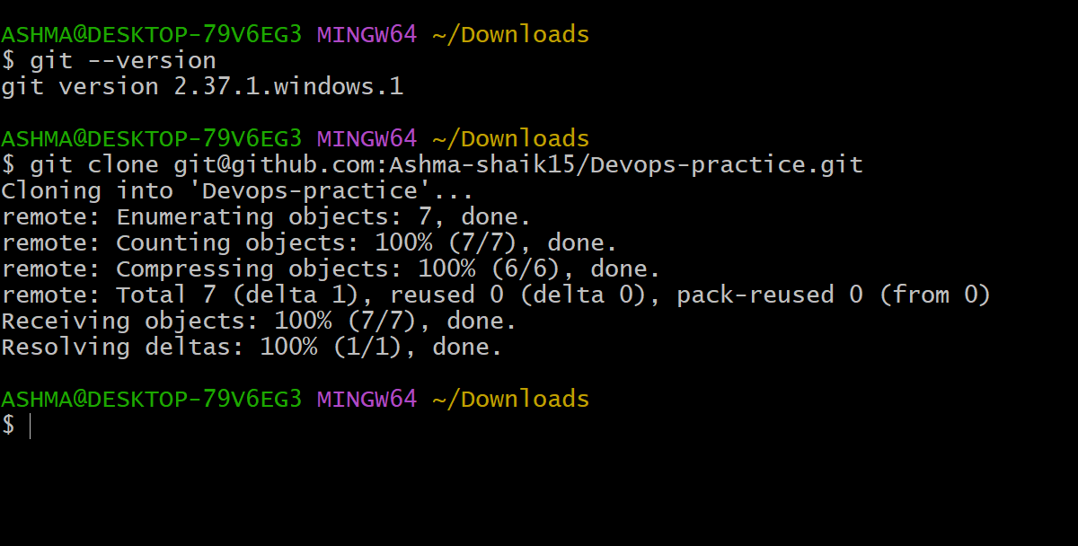4.Create two files in local repo.
- To create file Touch “file name”
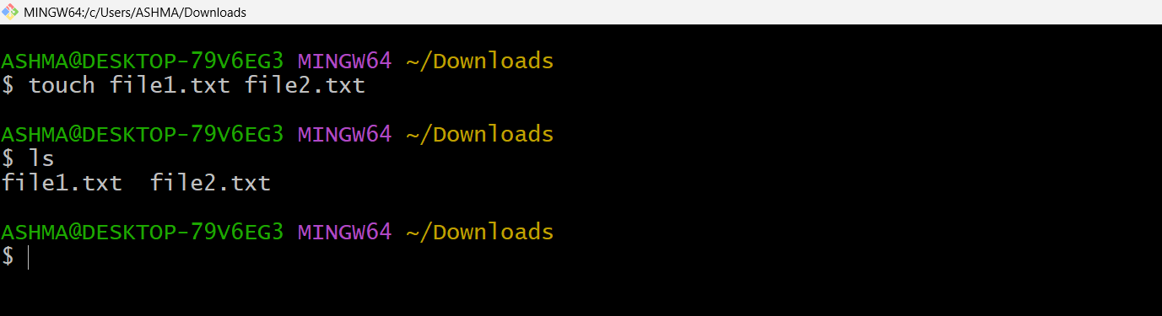
- Commit two files and push to central Repository.
- Create a local repository — Create files such as file1.txt and file2.txt in your project folder.
- Initialize Git — Use git init if the folder is not already a Git repository.
- Configure Git — Set your username and email.
- Stage and commit files — Use git add . and git commit -m "Initial commit".
- Connect to GitHub — Configure the remote repository using git remote add origin <repository-url>.
- Fetch remote changes — Use git fetch origin to retrieve the latest remote branch information.
- Pull and integrate changes — Integrate the remote main branch before pushing, because GitHub rejected your previous push due to existing remote changes.
- Push to GitHub — Use git push -u origin master:main if your local branch is master and the remote branch is main.

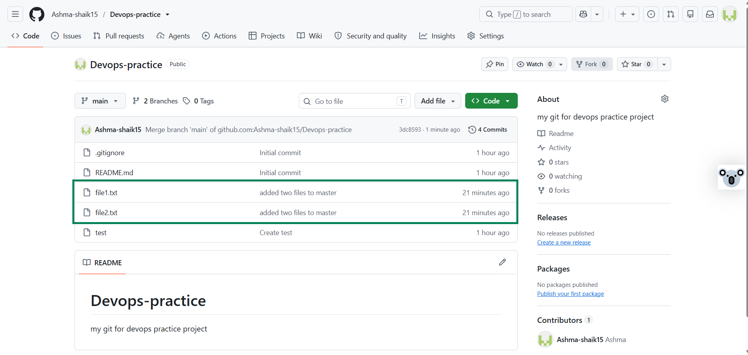

- Create a branch in local and create a sample file and push to central.
- Created new branch In local git branch hotfix
- Check the list git branch –list
- Switch to hotfix git checkout hotfix
- Create a file touch hello
- Add git add .
- Git Commit –m “added file”
- Git push –u origin HEAD
- Git branch –a
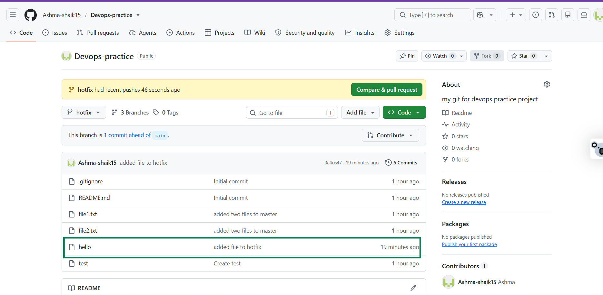
7.Create a branch in github and clone that to local.
- Create a branch in github release
- Clone to local git clone ssh url
- Retrieves remote branch updates git fetch origin
- Creates and switches to a local tracking branch git checkout release
- Lists local and remote branches git branch –a
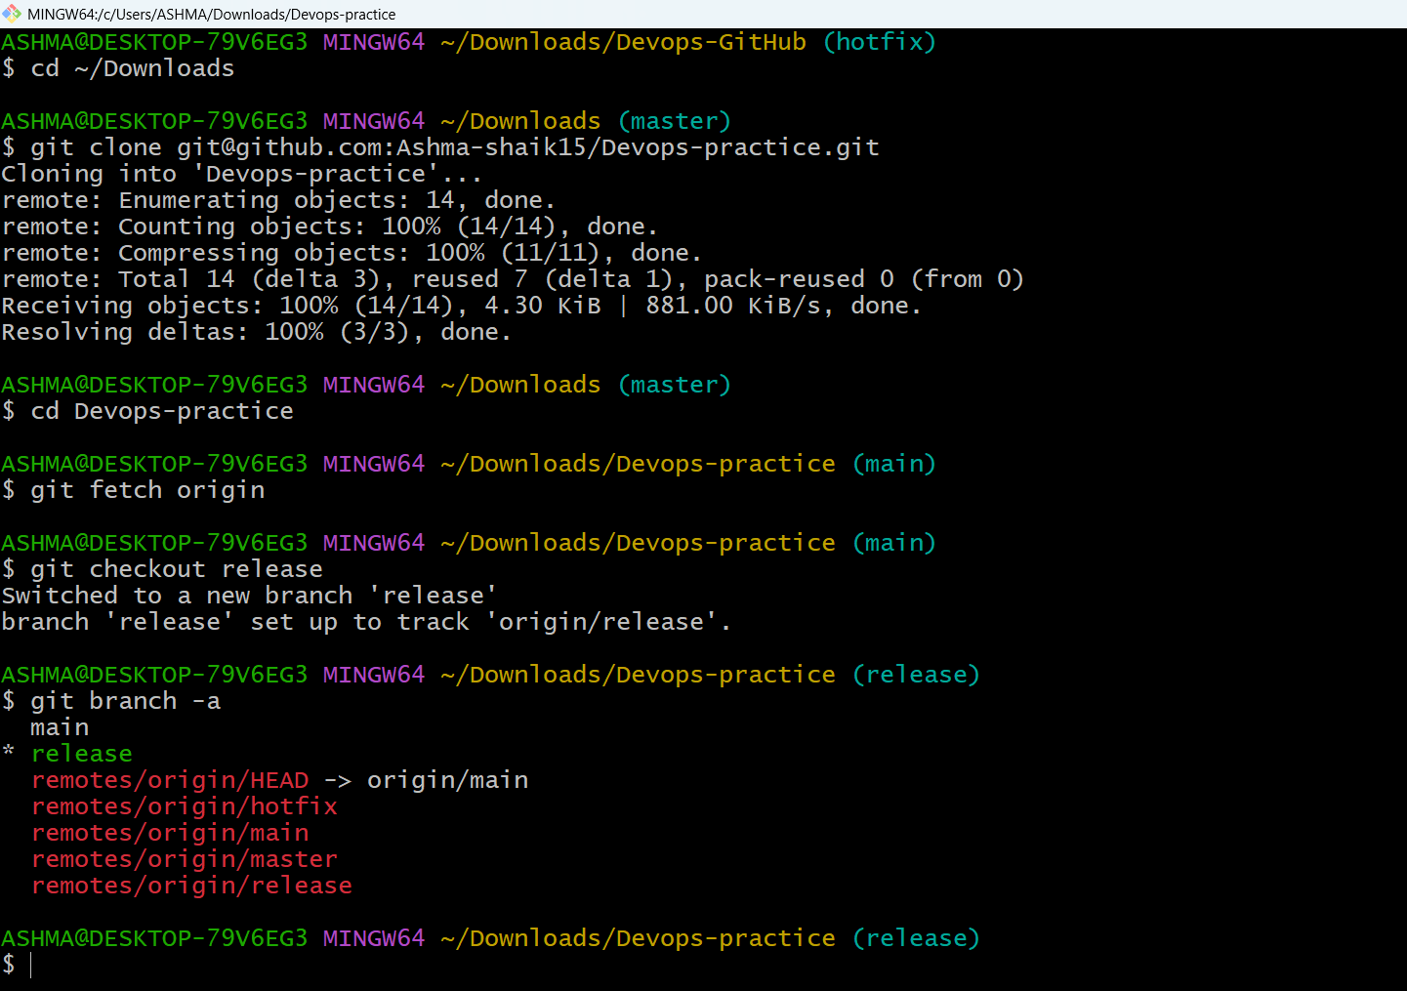
8.Merge the created branch with master in git local.
- git branch Lists local branches
- git switch master Switches to master
- git merge release Merges the created branch into master
- git log -1 --graph --all Displays branch and commit history
- git push origin master Uploads the merged changes to GitHub
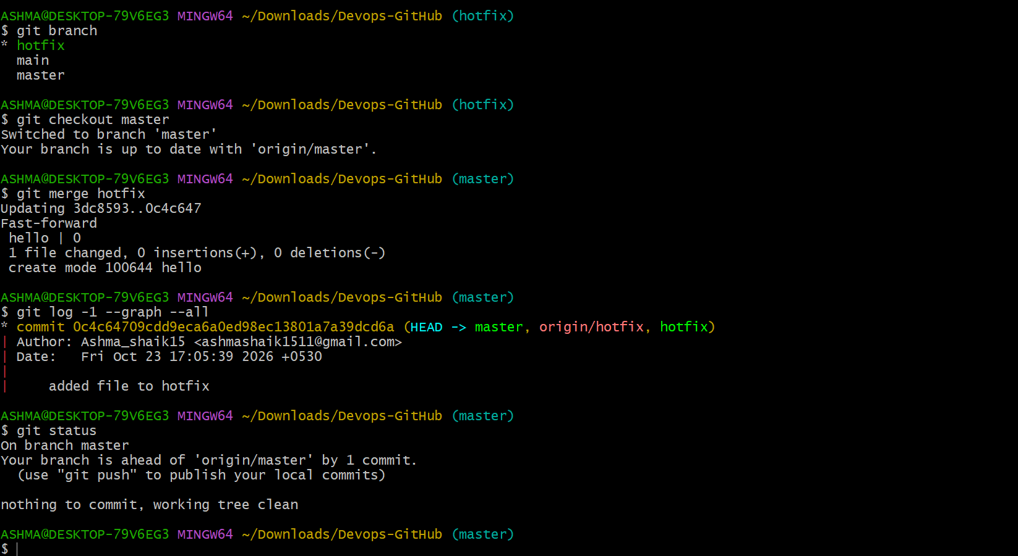
9.Merge the created branch with master in github by sending a pull request.
- Create a branch in your GitHub repository, such as release.
- Make changes to a file in the release branch.
- Commit and push the changes to GitHub.
- Open your GitHub repository in the browser.
- Click the Pull requests tab.
- Click New pull request.
- Select the branches:
- Base: master — the branch that receives the changes.
- Compare: release — the branch containing your changes.
- Click Create pull request.
- Enter a title and description, then click Create pull request.
- Review the changes and click Merge pull request.
- Click Confirm merge to complete the process.
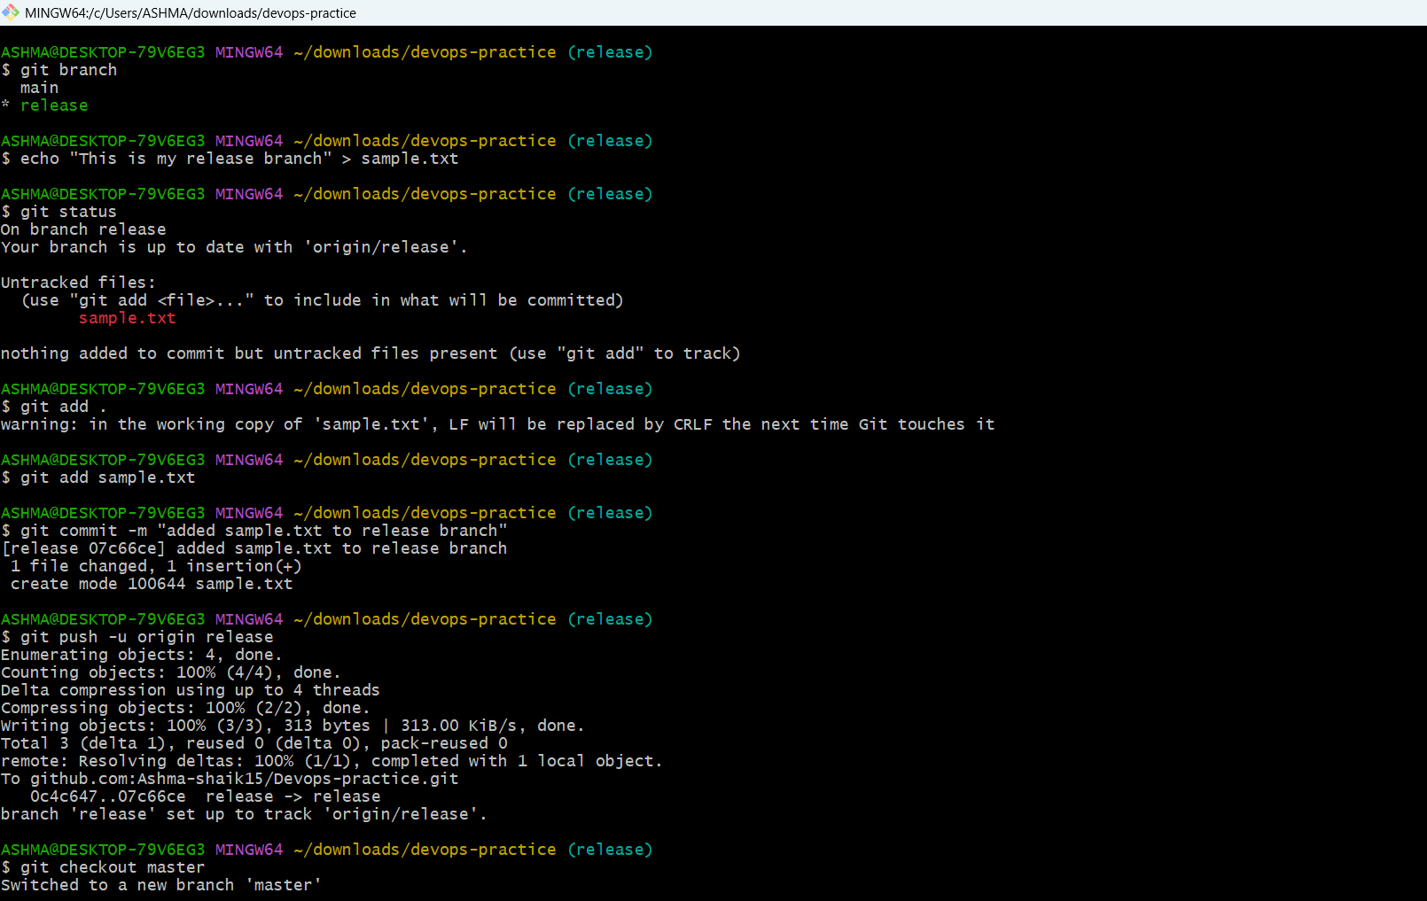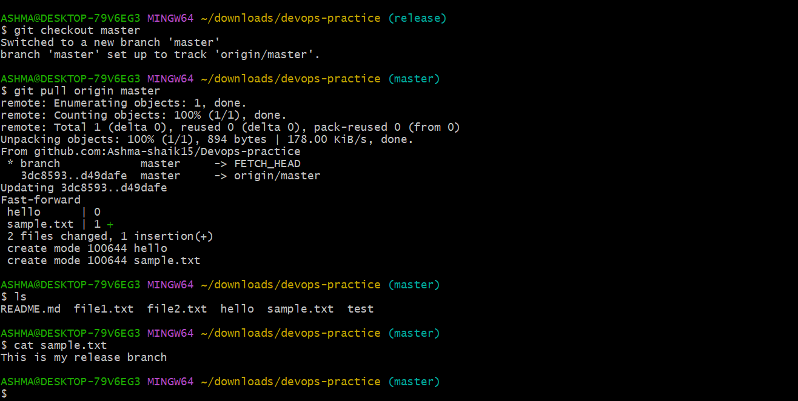
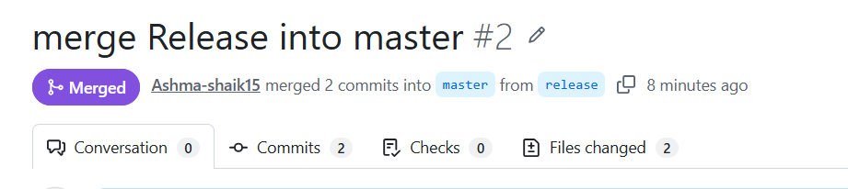
10.Create a file in local and send that to branch in github.
- Switch to release branch
- Create sample file
- Read file cat sample.txt
- Git add
- Git commit –m
- Git push –u origin release
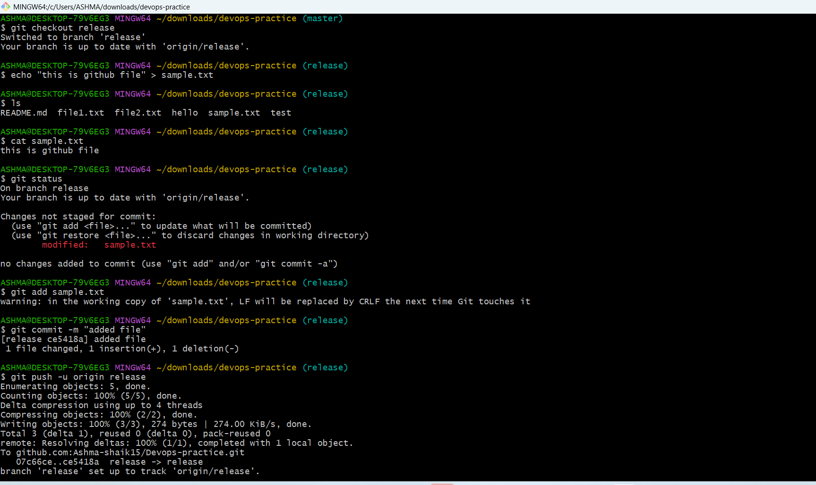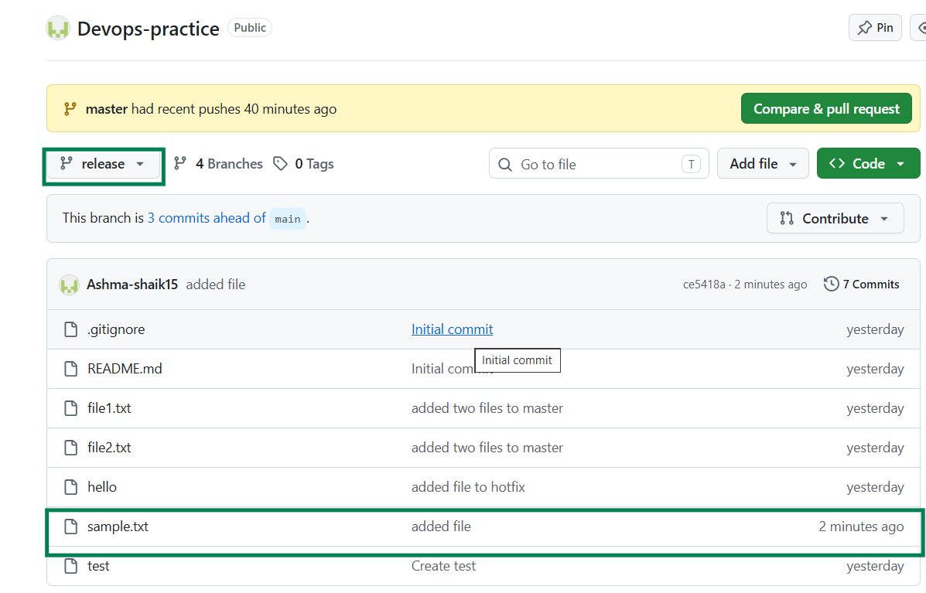

11.Clone only a branch from github to local.
- Clone a specific branch git clone --branch release --single-branch REPOSITORY_URL
- Enter repository cd my-repository
- Check current branch git branch
- Check remote branches git branch -r
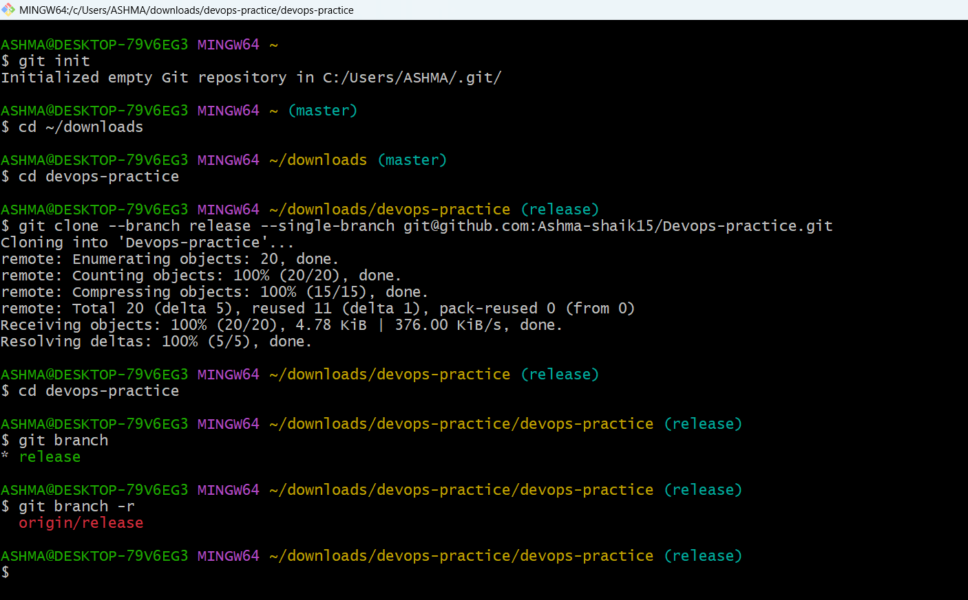
12.Create a file with all passwords and make that untrackable with git.
- Create a file vi secret
- Enter username and password
- Vi .gitignore
- Modify
- Git add .
- Git commit –m “modified”
- Git push –u origin release
- Check repository

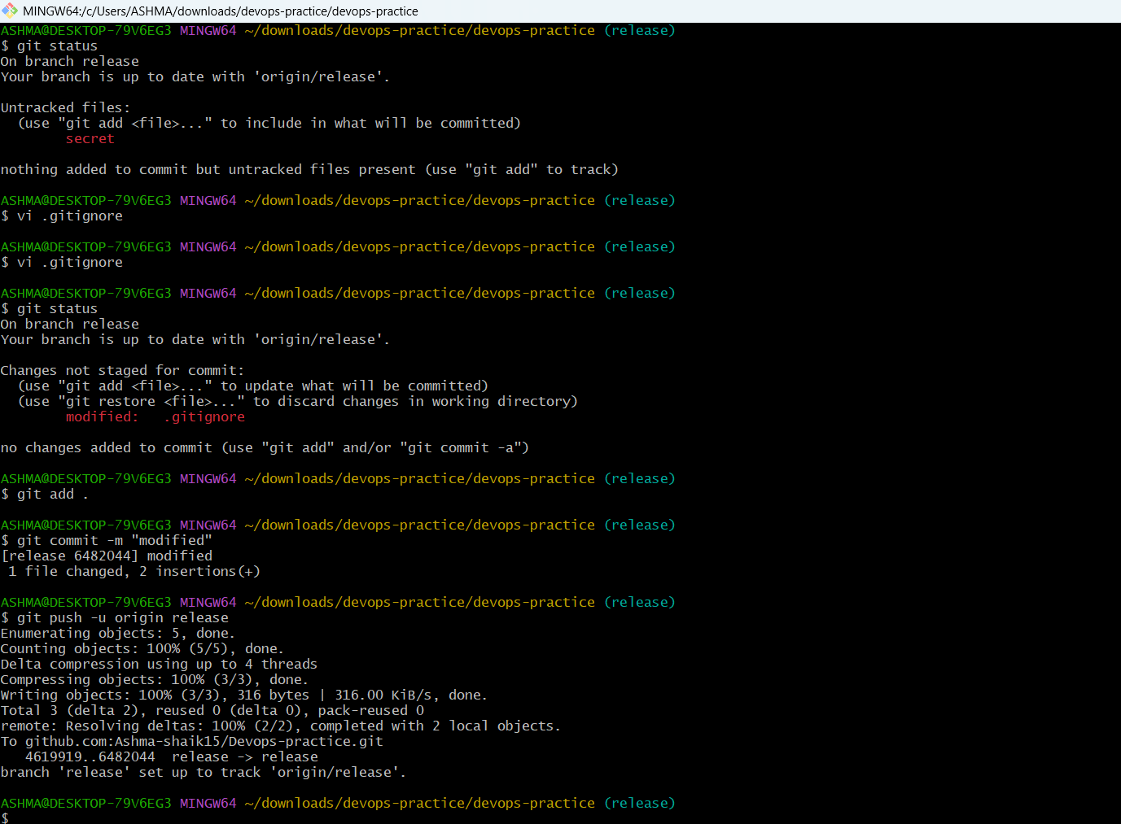
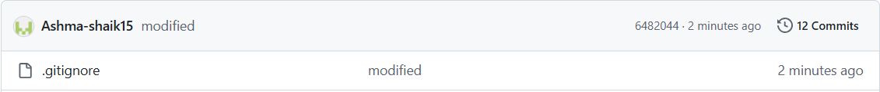
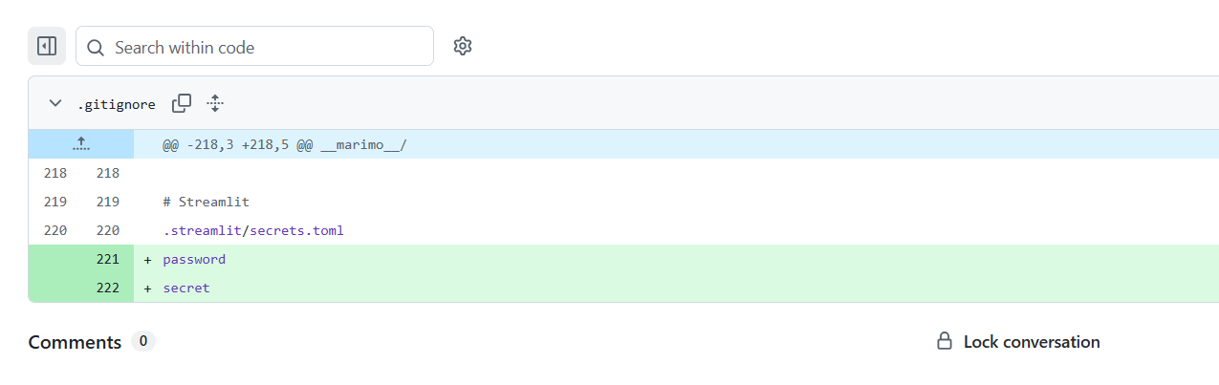
13.Make a commit and make that commit reset without savings changes.
- Create a file echo "Test" > reset-demo.txt
- Stage changes git add reset-demo.txt
- Commit changes git commit -m "Add reset demo file"
- Reset and discard changes git reset --hard HEAD~1
- Verify status git status

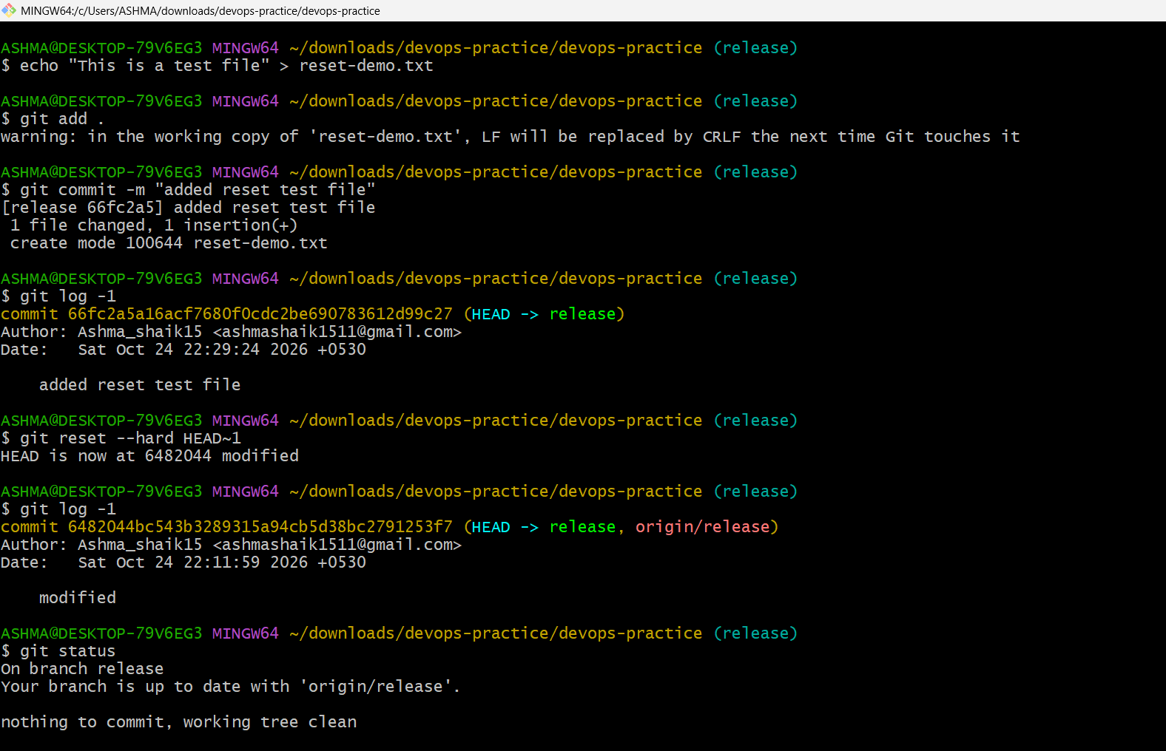
14.Revert a commited commit to the older version.
- View history git log --oneline
- Revert latest commit git revert HEAD
- Check status git status
- Push revert git push origin release
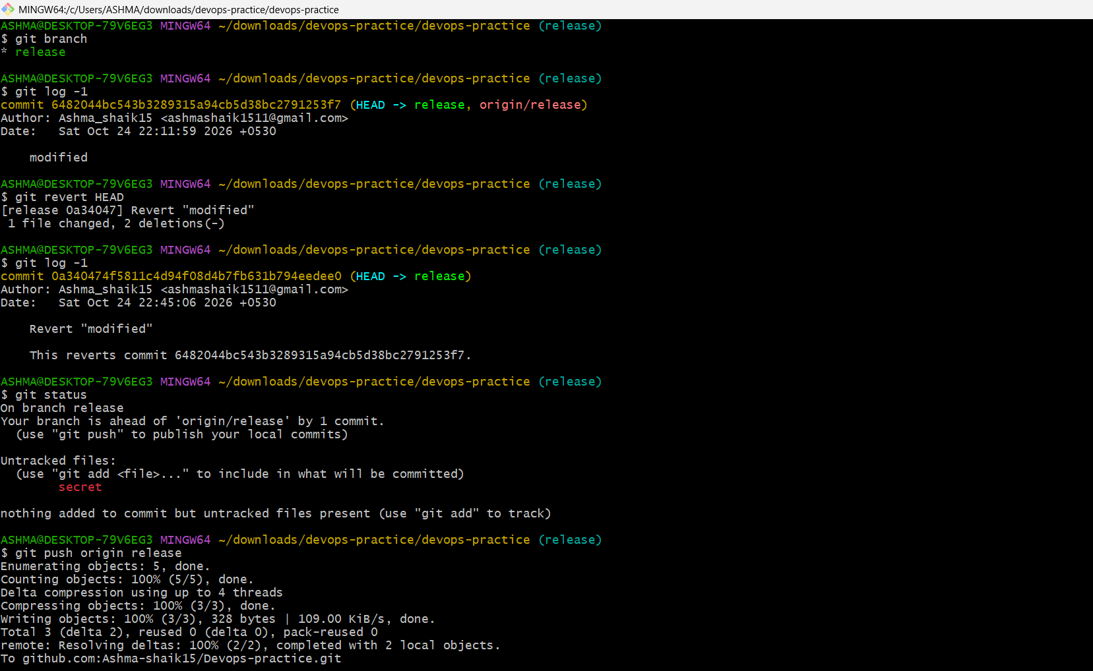

15.Push a file to stash without savings the changes and work on another file
- Stash changes git stash
- View stashes git stash list
- Work on another file vi hello
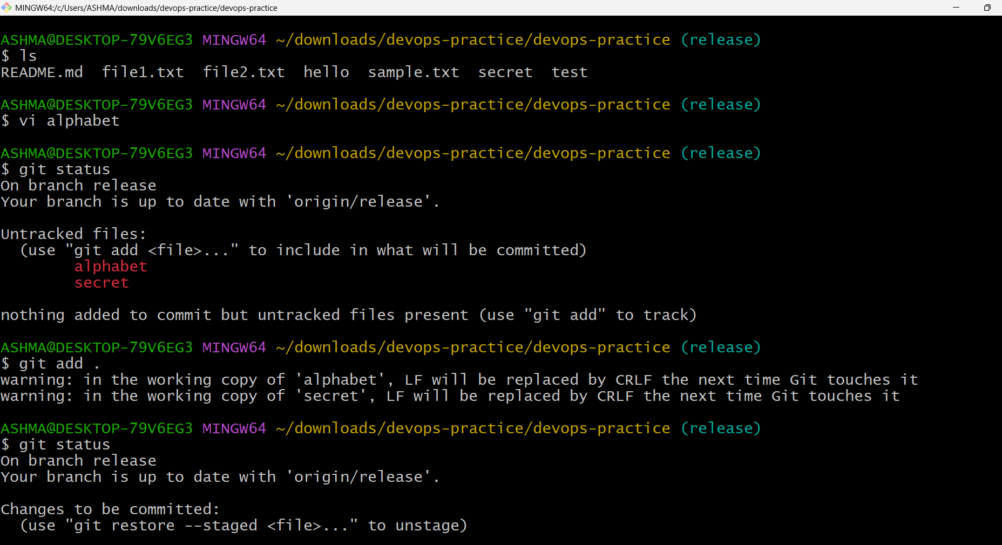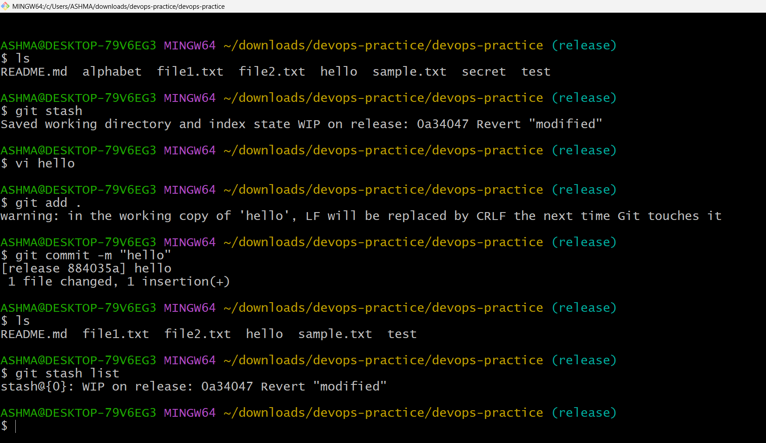
16.Undo the stash file and start working on that again.
- Git stash pop to get that file back
- Ls list of files
- Alphabet file is bak
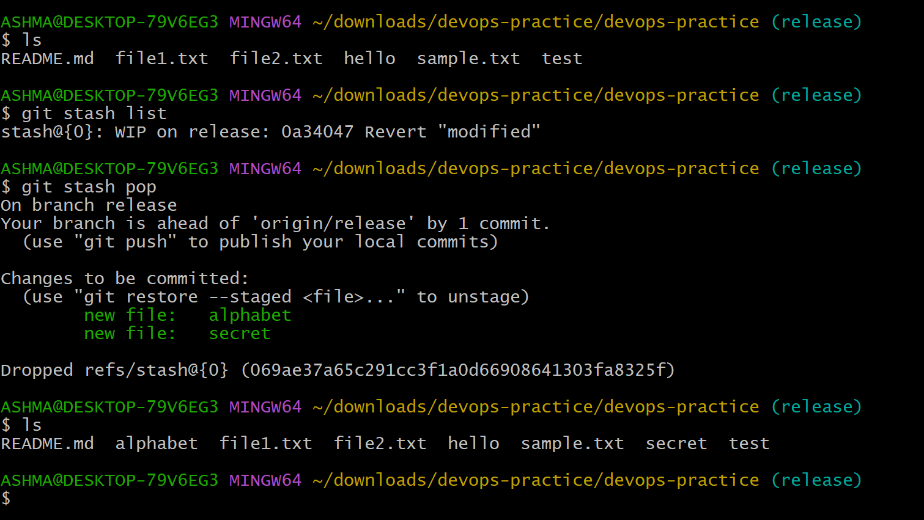
17.Generate a ssh-keygen and configure into github.
  - Generate key ssh-keygen -t ed25519 -C "your_email@example.com"
  - Start SSH agent eval "$(ssh-agent -s)"
  - Add private key to agent ssh-add ~/.ssh/id_ed25519
  - Display public key cat ~/.ssh/id_ed25519.pub
  - Test GitHub connection ssh -T git@github.com
  - Check remote URL git remote -v
  - Fetch from GitHub git fetch origin
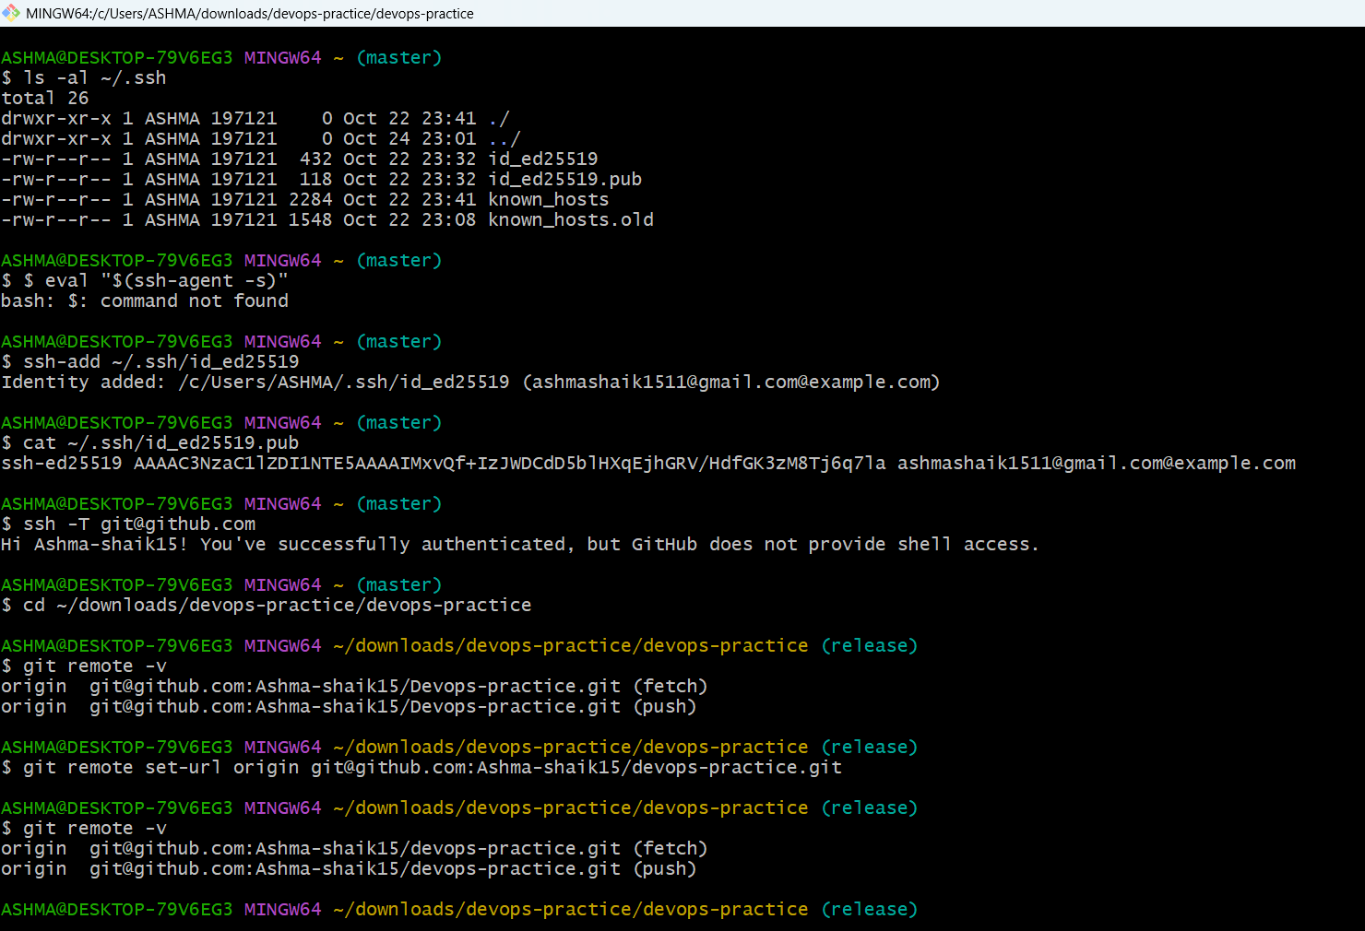
18.Configure webhooks to github.
- Open webhook settings Repository → Settings → Webhooks
- Create webhook Click Add webhook
- Choose event Push event
- Save configuration Click Add webhook
- Trigger test Commit and push a change
- Check result Recent Deliveries
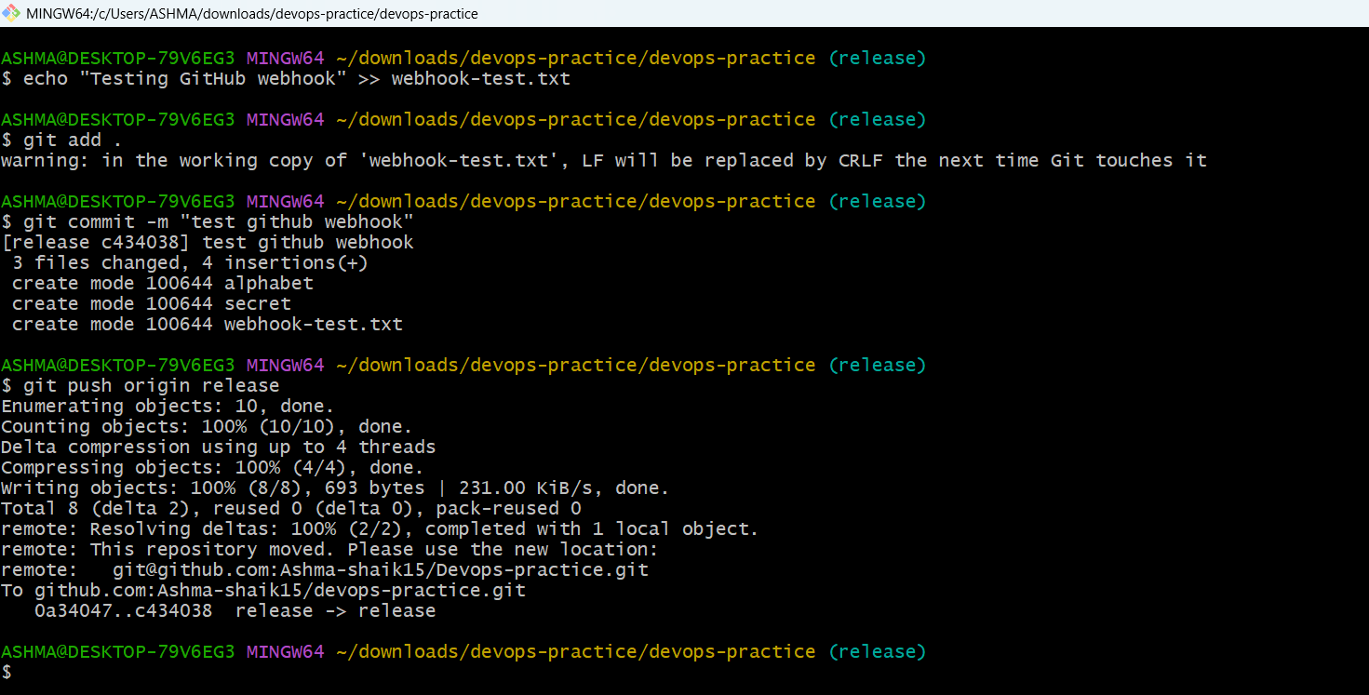
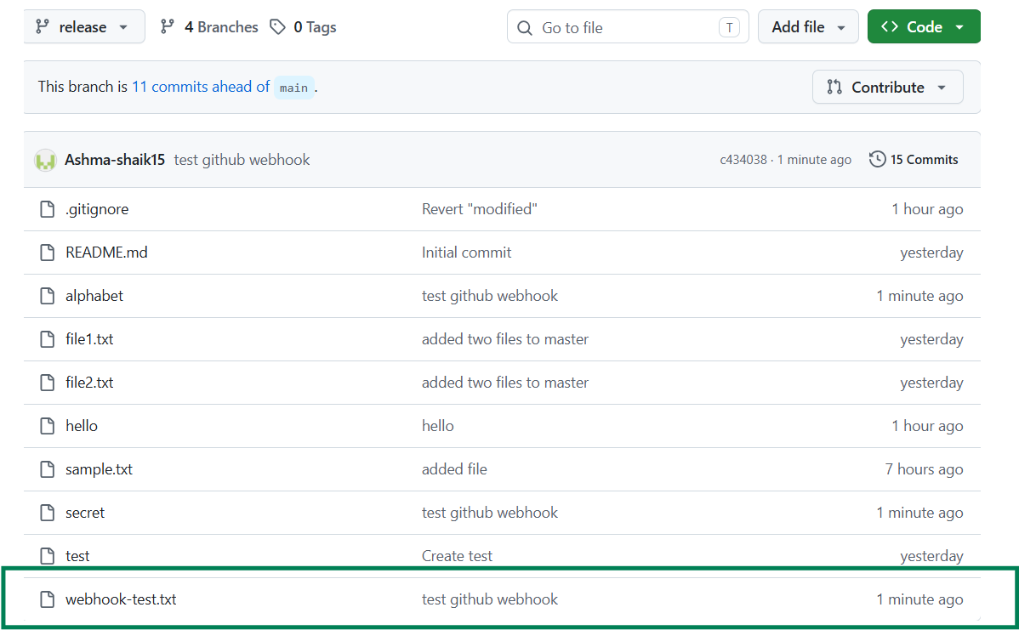
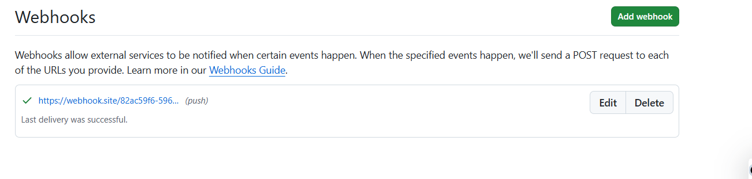
19.Basic understanding of .git directory.
- objects/ Stores Git objects, including file contents, commits and directory trees.
- refs/ Stores references to branch and tag commits.
- HEAD Indicates the current branch or checked-out commit.
- config Stores repository-specific configuration.
- index Stores the staging area's information.
- logs/ Records changes to references, such as branch movements.
- hooks/ Contains sample or custom scripts that run at certain Git events.
Important: These are internal Git files. You normally use Git commands to manage them instead of editing them manually.
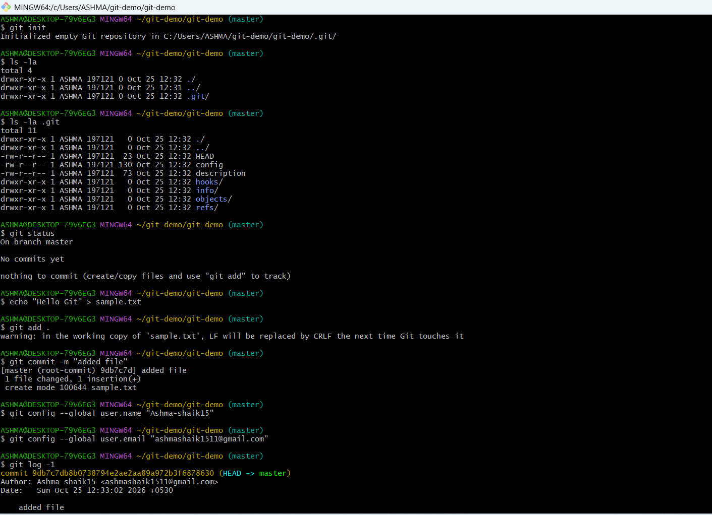

20.Check all the logs of git.
- Git log Commit ID
Author name
Date and time
Commit message
- Git log -1 View logs in one line
- Git log –p View detailed logs with changes
- Git log –all Check logs for all branches
- For a compact view showing branch names and commit relationships: git log --all --oneline --graph –decorate
- Git log -5 Check the last 5 commits
- Git log –apt.txt Check logs of a specific file
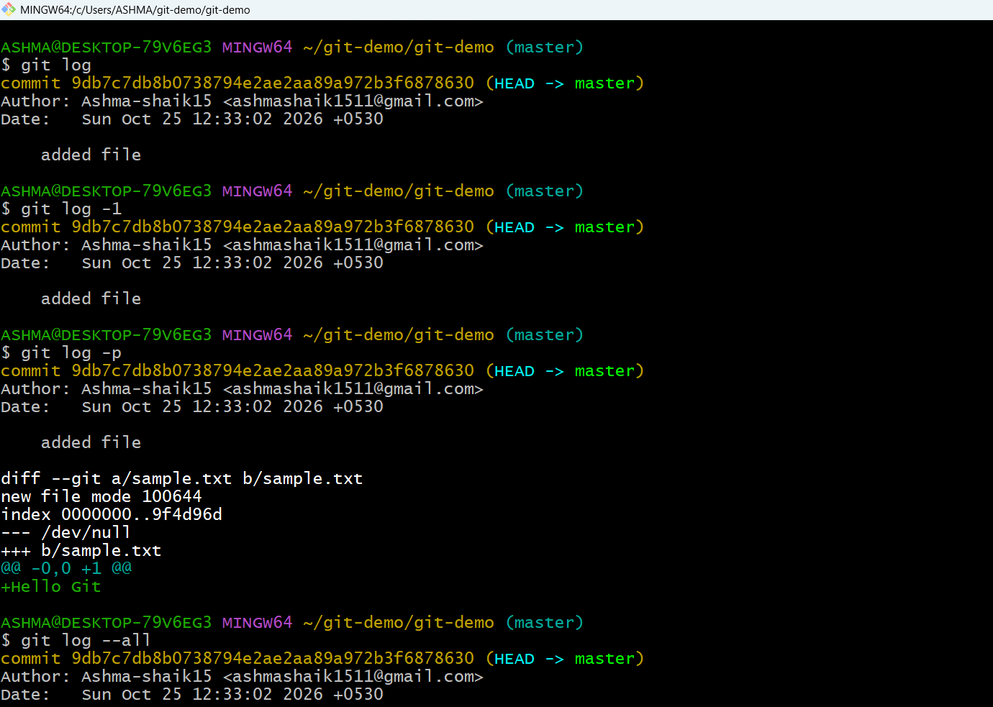
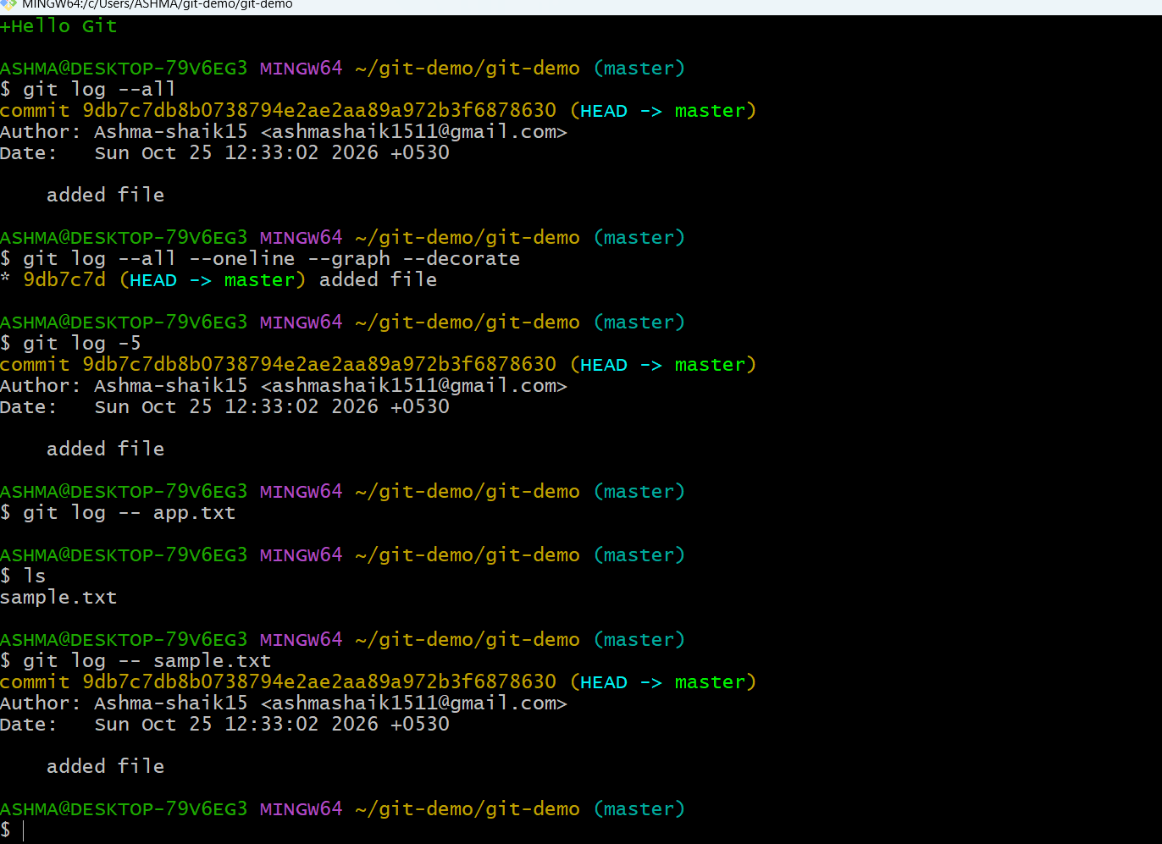

21.Rename the commit message.
- To rename commit message – git commit –amend
- To check git log
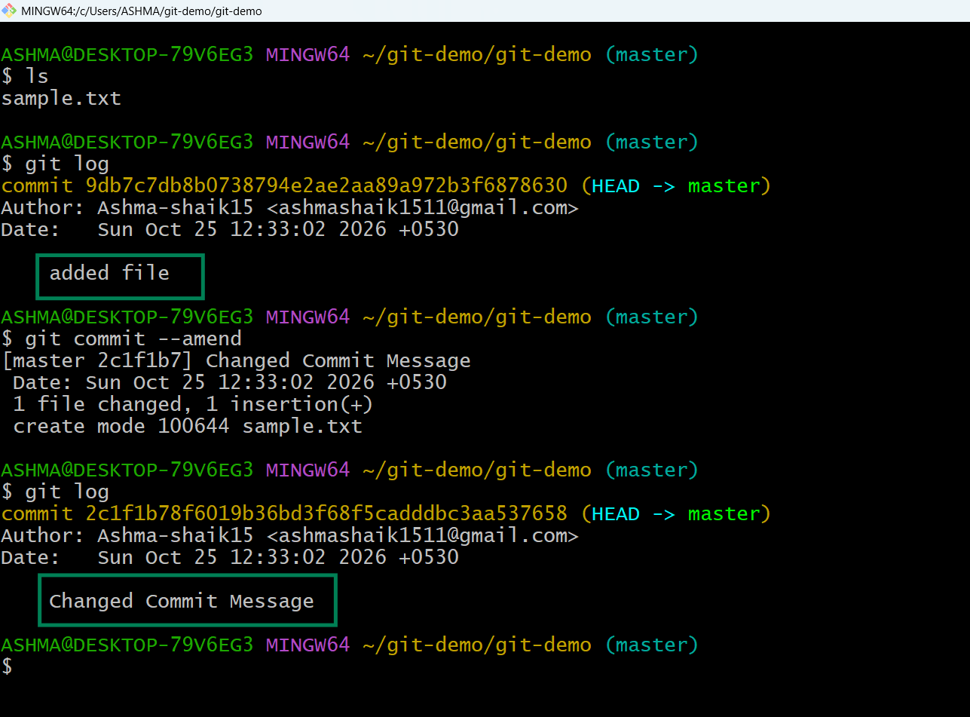
22.Merge multiple commits into single commit.
    - git log --oneline Check commit history
    - git add filename Stage a file
    - git commit -m "message" Create a commit
    - git rebase -i HEAD~3 Edit the last three commits
    - pick Keep a commit
    - squash Combine a commit with the previous commit

